ANNUAL REPORT
2022-2023

H I G H L I G H T S

    - An Overview
    - Common Activities of the Department
    - Student Enrolment and Student Diversity
    - Curriculum Enrichment Activities
    - Teaching Learning Sessions
    - Students Performance and Learning Outcomes
    - Student Support
    - Student Progression
    - Students’ Participation and Activities
    - Teachers’ Profile

AN OVERVIEW.....

The academic year 2022-23 was immeasurably splendid and the department has made giant strides towards its glorious future. Our team work was tremendous that we did our best to do as we had planned and we are proud of our students who strive hard to achieve beyond their potential.
In the academic year 2022-2023, 56 students were admitted (Female-30 and Male- 26) to I BBA batch, however due to the drop outs of 2 students in the batch, the department has managed altogether 141 students (Female-71 and Male-70). The academic year also witnessed the progression of the students in their higher studies, vocational engagement etc.
I feel extremely glad, proud and privileged to present the Department Annual Report, the gist of our activities and achievements of the Academic Year 2022-23

FACULTIES

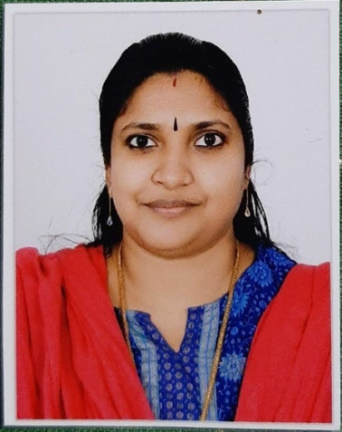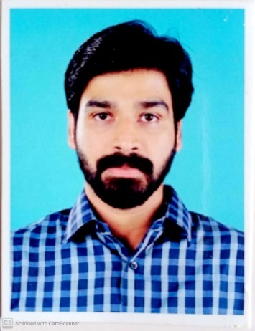
M GREESHMA PAVITHRAN – HOD SANGEETH K
(M.Com, MBA, M Ed) (MBA)

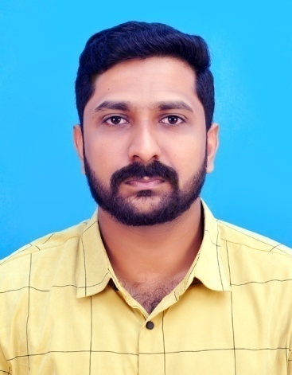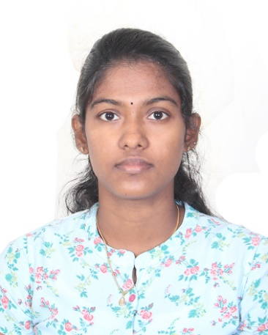
VINIL P VISWANATH MAHITHA T V
(MBA) (MBA)

COMMON ACTIVITIES OF THE DEPARTMENT

- Absentees SMS alert- Whatsapp group PTA
- Internal Assessment
- PTA Meeting
- Documentation of activities
- Alumni Data
- Basic Data Sheet
- Bridge course
- Scholarship
- Department Chronicle
- Internal Marks Split ups
- Semester wise University Question papers
- Industrial Visit
- Study Tour
- Students Achievement
- Blood Donors Data
- Faculty Participation

1. STUDENT ENROLMENT PROFILE & STUDENT DIVERSITY
1.1 STUDENT ENROLMENT PROFILE
CATEGORY | I BBA | II BBA | III BBA | TOTAL
Male | 25 | 25 | 20 | 70
Female | 29 | 23 | 19 | 71
Urban Area | 46 | 48 | 21 | 115
Rural Area | 08 | - | 18 | 26
APL | 41 | 42 | 25 | 108
BPL | 13 | 06 | 14 | 33

1.2 STUDENT DIVERSITY
 |  | I BBA | II BBA | III BBA | TOTAL
RELIGION | Hindu | 17 | 12 | 12 | 41
 | Muslim | 32 | 34 | 23 | 89
 | Christian | 05 | 02 | 04 | 11
CATEGORY | SC/ST | 01 | - | - | 01
 | OBC | 45 | 46 | 25 | 116
 | General | 08 | 02 | 14 | 24

2. CURRICULUM ENRICHMENT ACIVITIES
- INTER DEPARTMENT BUSINESS QUIZ : BBA 2020-2023 BATCH Conducted on 22/09/2022
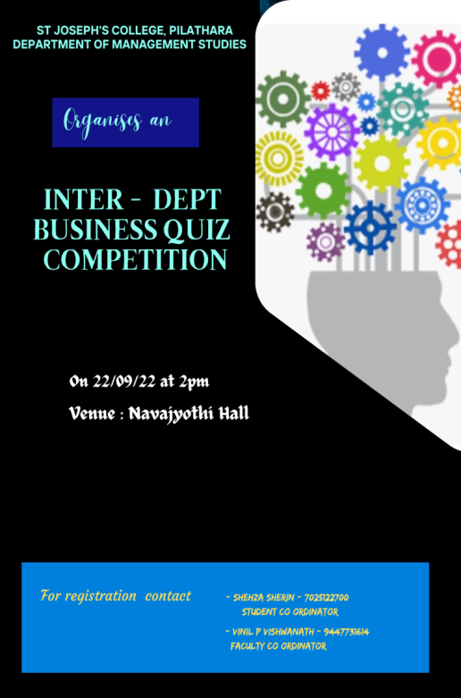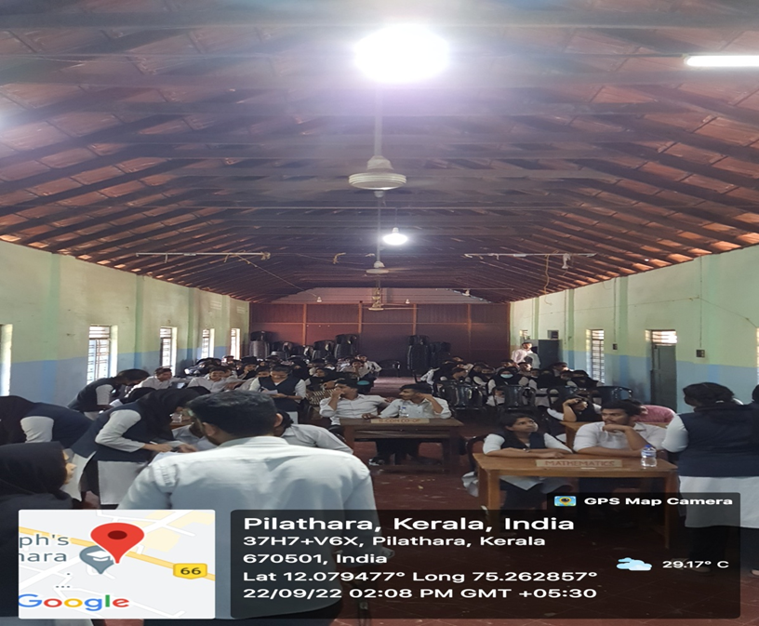

- “A TALK ON STOCK MARKET: INVESTMENT OR TRADE” - session by Mr. Abdul Musawir (Alumnus BBA 2019-2022 Batch) on 01/11/2022

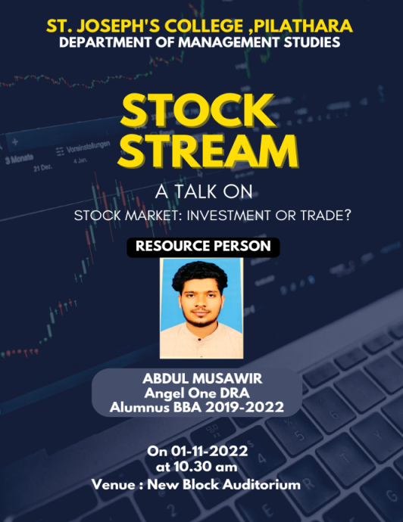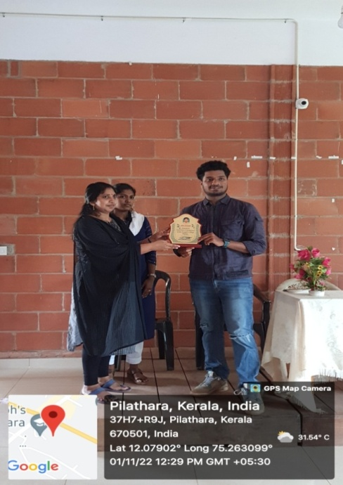
- A Session on: “LITERACY AND NUMERACY” by Vinil P Viswanath on 16/09/2022
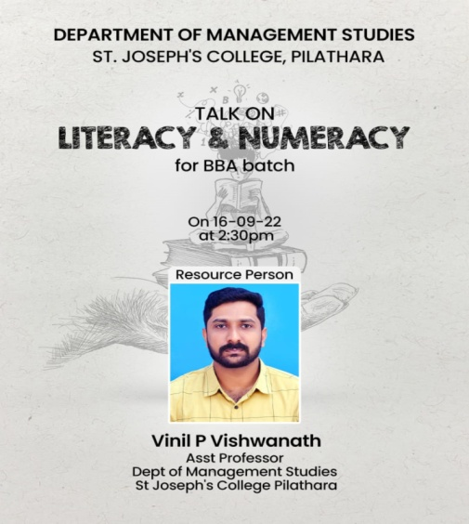

- MANAGEMENT TRAINING –WORKSHOP ; Selected Students from Dept Of Management Studies participated in the Workshop organised by Vimal Jyothi Institute of Management and Research, Chemperi on 07/02/2023

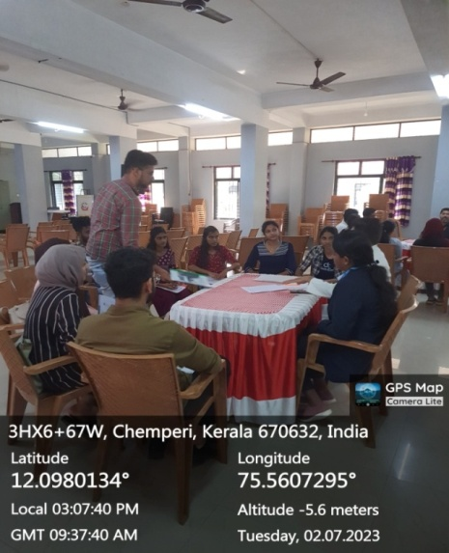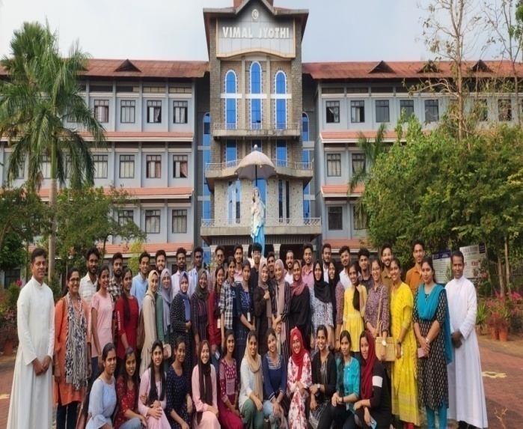

- “PADAVU” workshop was conducted on 7-10-22 for 2021-2024 batch
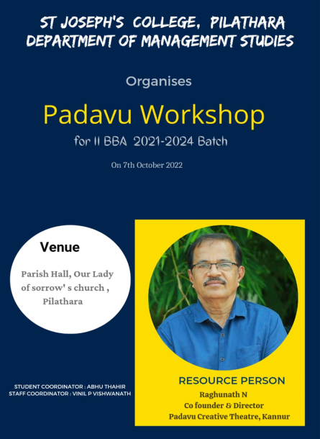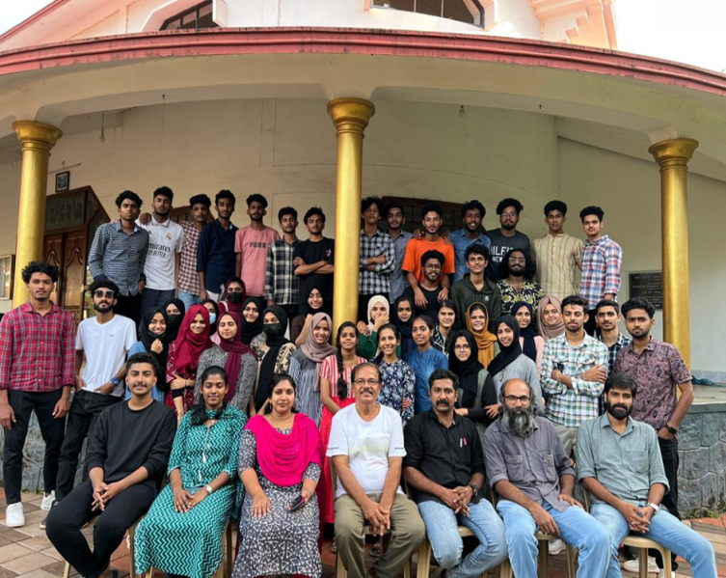

- Department conducted Study Tour for the final year BBA(2020-23 Batch) to Kodaikanal, Ramakalmedu, Wagamon from 19/01/23 to 23 /01/23

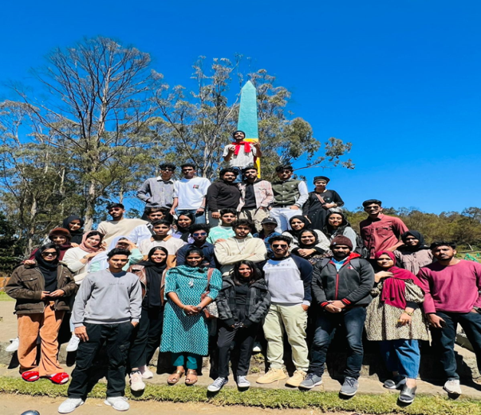

- Industrial Visit

  - 2020-2023 batch Visited Modern Food Enterprises Private Limited (MFEPL), Kochi Prince Polymers, Aluva on 12/06/22 to 15/0622.
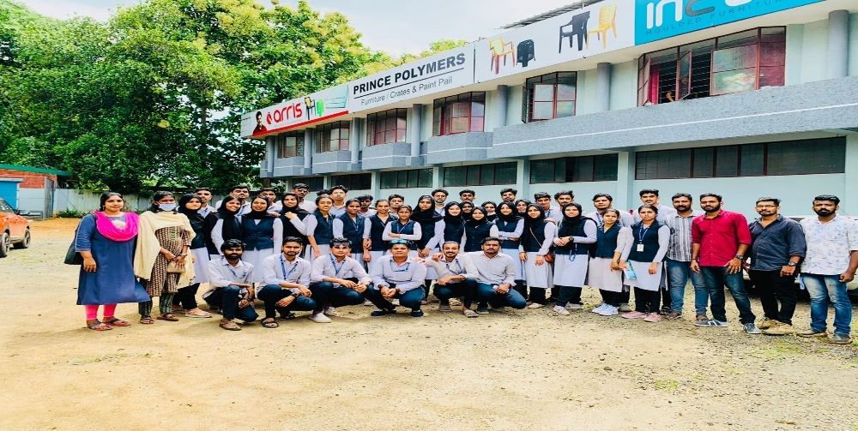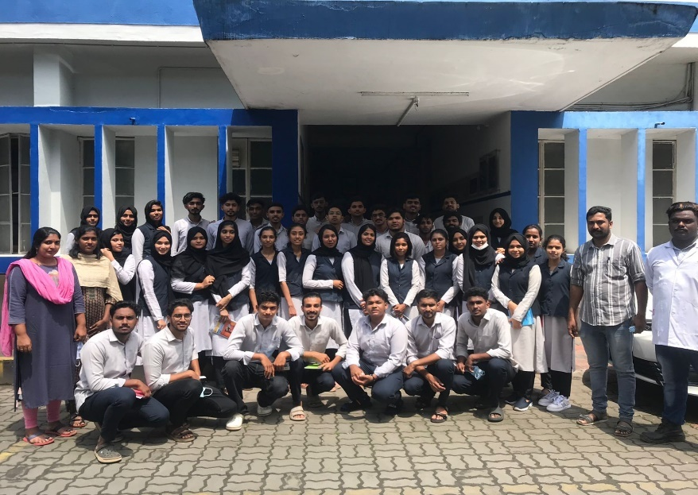

  - 2020-2023 batch Visited Western India Plywood and Milma, Kannur on 24/06/2022

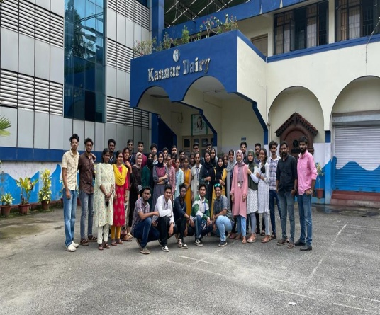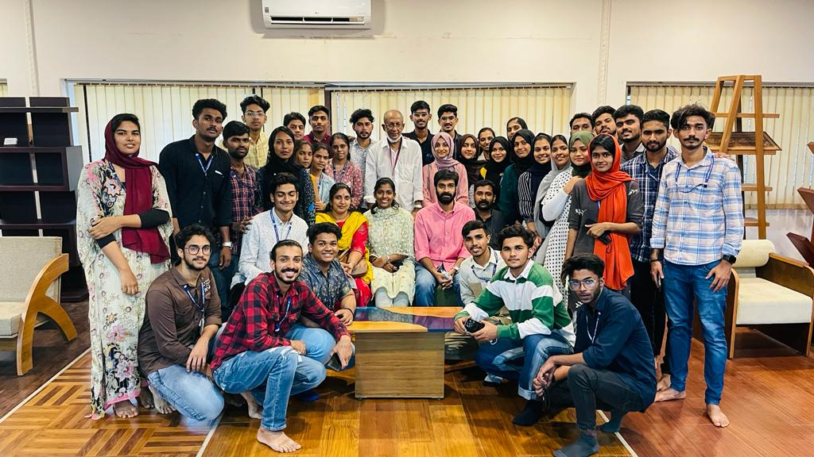

  - 2021-2024 batch Visited Chiripal Poly Films Ltd. Hyderabad for II BBA batch from 19/01/2023 to 24/01/2023.
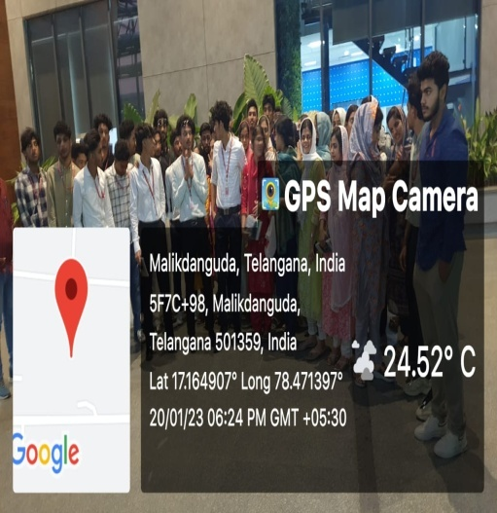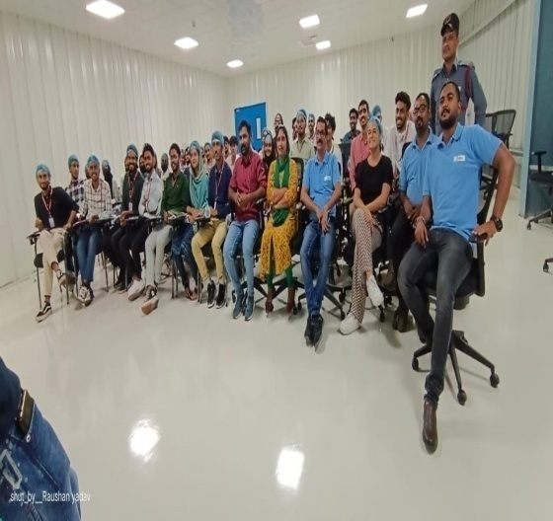

3. TEACHING LEARNING SESSIONS
- College level and Department level Orientation 1st Semester BBA students and parents on 15/09/2022.
  - Mr Umeshan Poogodan, Parent of Sneha and Mrs. Sandhya parent of Vyshnav were selected as PTA representative
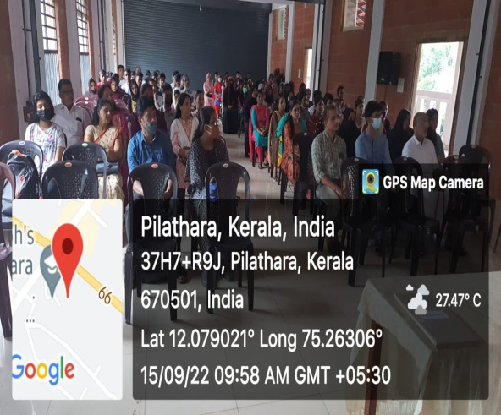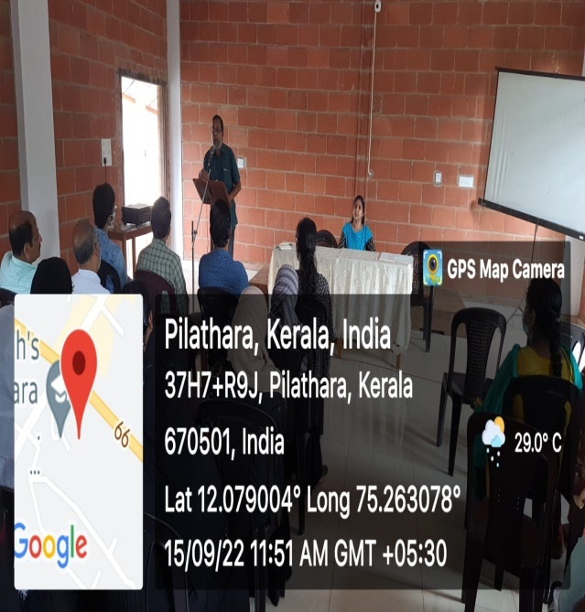

- Uploaded the study materials in ETLAB
- FRESHER’S DAY Celebrated on 14/11/2022
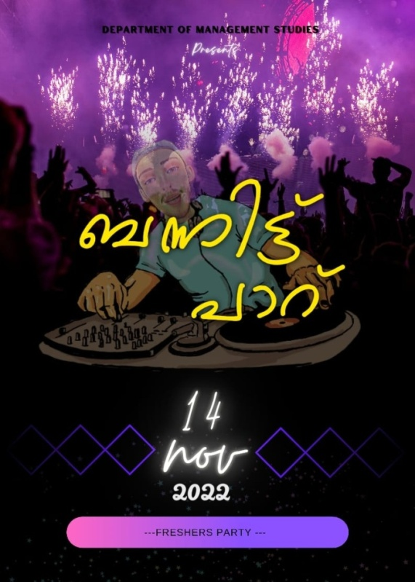
- ORIENTATION ON ADD ON COURSE - CMA FOR First year students and parents on 14/10/22 at New Block Auditorium
- The department have bagged first prize in the Food Fest organised by the Union of St Josephs college , Pilathara on 13/02/23
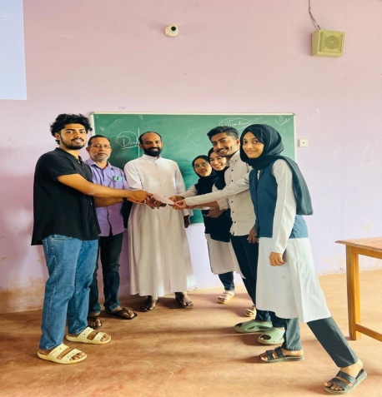

- Department Meeting

In the academic year 2022-2023, the department hosted 12 meetings in the department staff room for the active discussion on student’s progression and faculty updation activities.
Sl No: | Date
1 | 21/06/2022
2 | 13/07/2022
3 | 24/08/2022
4 | 25/08/2022
5 | 14/09/2022
6 | 19/09/2022
7 | 20/10/2022
8 | 22/11/2022
9 | 30/01/2023
10 | 03/02/2023
11 | 22/02/2023
12 | 17/05/2023

4. STUDENTS PERFORMANCE AND LEARNING OUTCOMES

In the academic year 2022-2023, 23 students graduated out of the 39attendees. The department succeeded in achieving the pass percentage 58.97, which is more than University average of pass percentage – 50.37. Out of the 23students passed, 01 student secured distinction, 16 students secured first class and 06 students secured third class. Ashiga T P (85.17), Fathimathul Safa K P (78.13) and Anusree K V (77.47) occupied the first, second and third position in the batch respectively. The chart below shows the result status of ‘2020-2023’ batch in each semester.

The first 3 Semester of ‘2021- 2024’ batch was also published, wherein the pass percentage include
- First Semester- 56.25%
- Second Semester- 47.91%
- Third Semester- 54.16%
OPEN COURSE
The academic year 2022-2023, the department offered only one Open Course – E Commerce when compared to last year, where two open courses were offered. The table below highlights the details of the open course offered by the department
Students Enrolled |  | Students Appeared | Students Passed | Pass %
Bcom Finance | 20 | 20 | 18 | 90
Bcom CA | 06 | 06 | 06 | 100
Bcom Co-op | 01 | 01 | 01 | 100
BA Eng | 11 | 11 | 11 | 100
BSW | 02 | 02 | 02 | 100
BSc Psychology | 03 | 03 | 03 | 100
Total | 43 | 43 | 43 | 100

Five students secured cent percentage in E Commerce
1. Mary Shyma T T (Bcom Finance)-100%
2. Muhammed Namshad Nasar (Bcom CA)-100%
3. Sawad C H (Bcom CA)-100%
4. Muhammed Ajmal V C (BA ENG)- 100%
5. Riya Mariya (Social Work) – 100%

5. STUDENT SUPPORT
A. POST ENTRY EXAMINATION
A post entry examination for the ‘2022-2025’ batch was conducted on 01/09/22
B. BRIDGE COURSE
The department faculties provided 15 hours bridge course programme for the new admitted students of 2022-2025 batch from12/09/22 to 22/09/22
SLNo: | FACULTY | TOPIC
1. | Mahitha T V | Introduction of Managerial Economics
2. | Sangeeth K | Introduction to Business Management
3. | Vinil P Viswanath | Basic Statistical & Numerical Skills

C. SCHOLARSHIP
The academic year 2022-2023, 30 students applied for the ‘Post Matric’ scholarship and the scholarship of 6000 rupees was sanctioned to only 1 student of II BBA
Batch | No: of students applied
I BBA | 11
II BBA | 12
III BBA | 07

D. CAREER GUIDANCE SESSIONS
- Career guidance session by LOGOS School of Management on 05/01/2023.
- Placement orientation programme by TALROP on 10/03/2023.
- CMA orientation by Chanakkaya Schools of Management on 12/01/2023.
- Career Guidance by Navalok Academy on 30/01/2023.
- Career Guidance ANIX Overseas Education on 09/03/2023.

6. STUDENT PROGRESSION
The department is extremely delighted to see the progression of the students, who joined in various universities for higher studies.
Sl No: | Name | Batch | Course | University
1 | Hisham C K | 2019-2022 | Msc HRM | University of Central Lancashire, UK
2 | Navaneeth Jay | 2019-2022 | MBA | Kristu Jayanthi School of Management, Bengaluru
3 | Abdul Vahid A P T | 2019-2022 | MBA | Sunway University, Malaysia
4 | Farzeena | 2019-2022 | MBA | Farook College, Calicut University
5 | Ebin Thomas | 2018-2021 | Msc Digital marketing | University of Chester
6 | Jidhin Pradeep | 2018-2021 | Diploma in Cinematography | Asian Academy of Film and Technology, Noida
7 | Muh. Shahid | 2018-2021 | MBA | University of Roehampton, London
8 | Muh. Favas | 2018-2021 | MBA | University of East London
CLASS PTA MEETINGS
The department have scheduled class PTA meeting for all batches.
Semester | Date
I | 15/12/22
II | 03/08/22
III | 19/07/22
IV | 21/03/23
VI | 13/03/23

7. STUDENT PARTICIPATION AND ACTIVITIES
A. KALOTSAVAM
- Anto James - Best Actor in English Drama (III A grade)
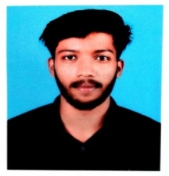
- Anto James , Anamika ,Khadeejath Shamreena participated in English Drama (III A grade)
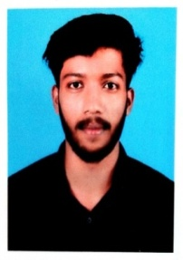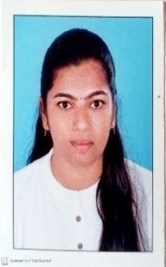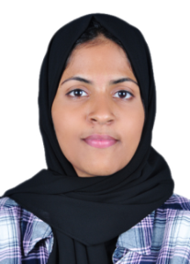

- Sankeerth Shaji participated in Mrudangam (II PLACE A GRADE )
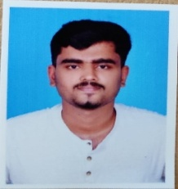
- Muhammed Jazir M K, Muhammed Saheer , Shammas participated in Arabana Muttu (II A grade)
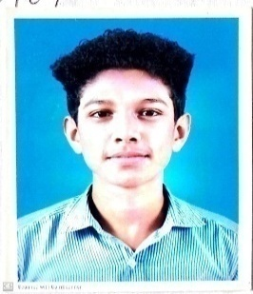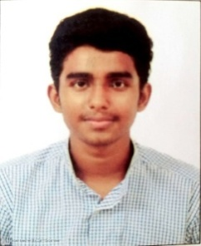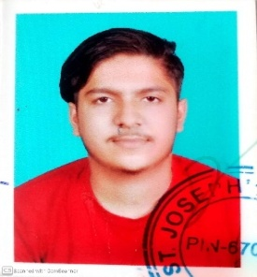
- Muhammed Jazir , Ansab participated in vattapattu (III A grade)
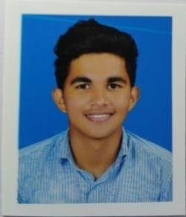
- Amal Mathew participated in Hindi drama(III A Grade)
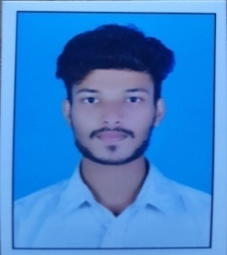
Other Participants in Kalotsavam
- Yadhukrishnan : Gasal ,western music
- Roshna : Hindi poem writing
- Fida Basheer : Mappilapattu, Oppana
- Greeshma : Oppana
- Fathima Ashraf : Embroidery

B. SPORTS
- Abhiram of I BBA got selection in District Junior Football Team
- College Cricket Team : Abdul Haseeb (II BBA), Hisham C K (II BBA)
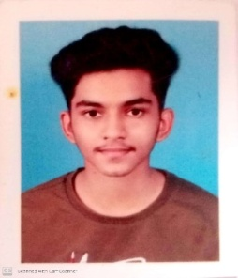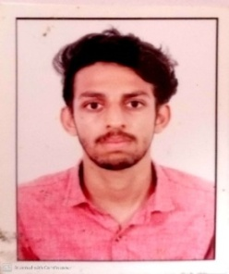
- College Football Team : Aflah and Ansab (III BBA),Saheer and Noufal Rayas (II BBA)
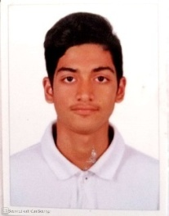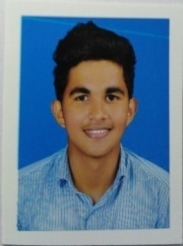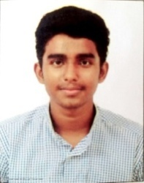
- Kannur Regional reliance cup champion : Saheer and Noufal
- Badminton Women : Fidha Basheer (II BBA)
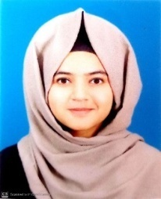
- College Basketball Team : Anto James(II BBA) and Muhammed Suhail Aalakkal
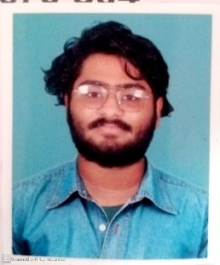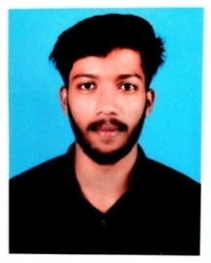
- Kannur University Taekwondo championship 2022 (Bronze medal): Vyshnav (I BBA
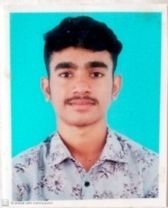

C.OTHER PARTICIPATION
- Three students enrolled add on course CMA by ISDC projects INDIA pvt Ltd.
1. Fathimath Nadha
2. Fathimathul Safa
3. Khadeejath Shamreena N
- Samra Sidique I BBA, Fida Basheer II BBA participated in “SPEEK FOR INDIA “programme held at Payyanur College.
- Muhammed Faris, Muhammed Suhail, Fida Basheer, Munees Muhammed participated in “Best Management Team” organised by College of Engineering, Thalassery.
- Muhammed Nihal Abdulla, Amal Mathew, Roshna Raj Nambair participated in “Best Manager” organised by College of Engineering, Thalassery.
D. NSS VOLUNTEERS
In the academic year 2022-23, 9 students from the I BBA batch have enrolled in NSS unit. Altogether the department composes 22 NSS volunteers.
E. BLOOD DONATION
In the academic year 2022-23, 6 students of the department donated blood in various days.
F. COLLEGE UNION
- Muhammed Shamil k p (III BBA)- General Secretary
- Aflah K N (III BBA)- III Year Department Representative
- Fathima Mujeebu Rahman(III BBA) – Association secretary

8. TEACHERS’ PROFILE
- M Greeshma Pavithran :
- Attended international conference on “Analytics – The Future” Organised by International Skill Development Corporation on 22/08/2022.
- Participated in 30 hour course on Foundations Of Education For Post Graduates and Researchers in Education organised by MHRD TLC, Dept of Education, University of Calicut on 22/05/2023 to 29/05/2023
- Attended Online workshop and Panel discussion on “Revised SSR Manual and Benchmarks for Affiliated College “ organised by IQAC MAR-IVANIOS College, Thiruvanthapuram on 28/03/2023.
- Mahitha T V pursuing M Com - IGNOU
KANNUR UNIVERSITY VALUATION CAMP
- M GREESHMA PAVITHRAN :
  - III Semester 30/05/2022 to 03/06/2022
  - I ,II,IV Semester 26/09/2022 to 12/10/2022
  - V Semester 19/12/2022 to 23/12/2022
  - I, IV &VI Semester 27/04/2023 to 20/05/2023
- SANGEETH K :
- III Semester 30/05/2022 to 08/06/2022
- I ,II,IV Semester 26/09/2022 to 12/10/2022
- V Semester 19/12/2022 to 23/12/2022
- I, IV &VI Semester 26/04/2023 to 24/05/2023
- VINIL P VISWANATH
  - III Semester 30/05/2022 to 10/06/2022
  - I ,II,IV Semester 26/09/2022 to 12/10/2022
  - V Semester 19/12/2022 to 20/12/2022

- MAHITHA T V
- III Semester 30/05/2022 to 03/06/2022
- I ,II,IV Semester 26/09/2022 to 12/10/2022
- V Semester 19/12/2022 to 23/12/2022
- I, IV &VI Semester 28/04/2023 to 19/05/2023

KANNUR UNIVERSITY EXTERNAL EXAMINER DUTY
- M GREESHMA PAVITHRAN:
External Examiner for IV semester BBA Project and Viva Evalution of Kannur University held at Sirsyed Institute for Technical Studies, Taliparamba on 24/04/2023.
- SANGEETH K :
External Examiner for IV semester BBA Project and Viva Evaluation of Kannur University held at Gurudev Arts and Science College, Mathil on 19/04/2023
- VINIL P VISWANATH :
External Examiner for IV semester BBA Project and Viva Evalution of Kannur University held at Payyanur College on 24/04/2023

PHOTO GALLERY
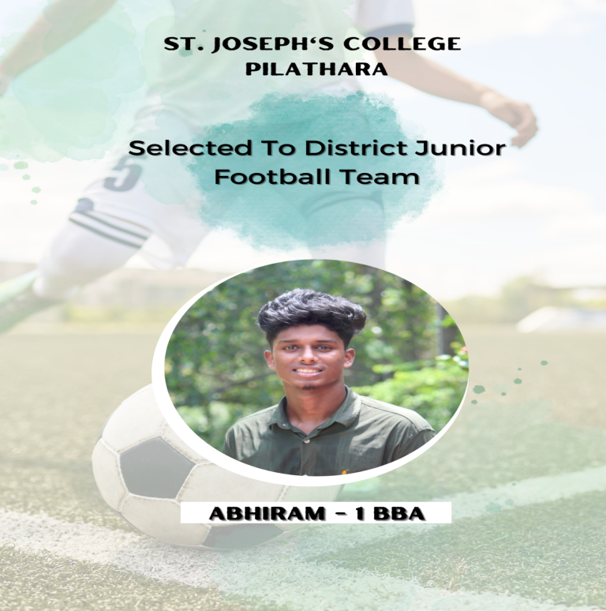

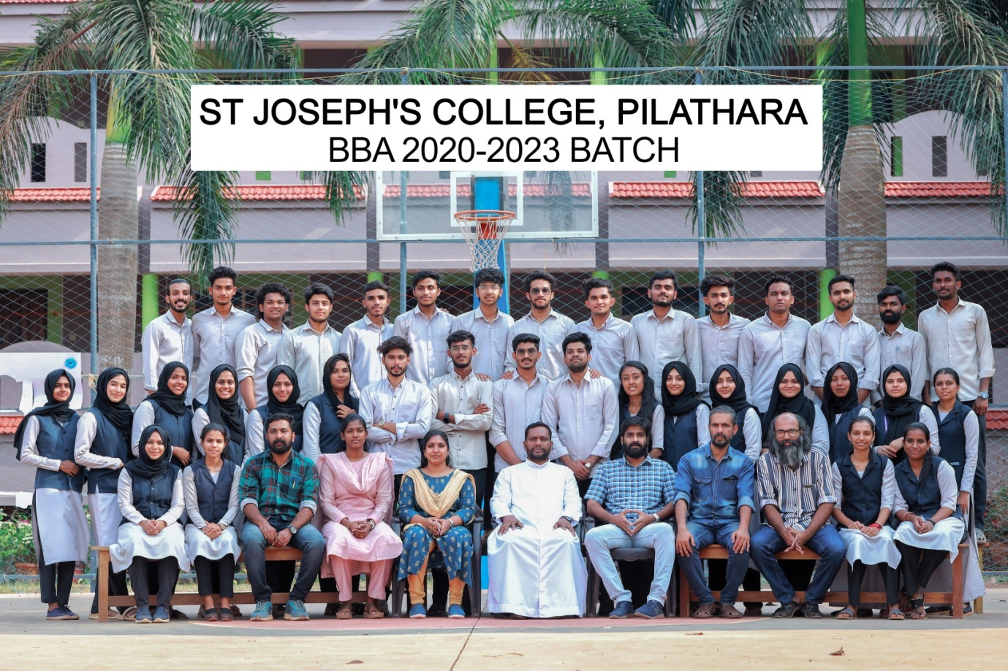

CLASS PTA
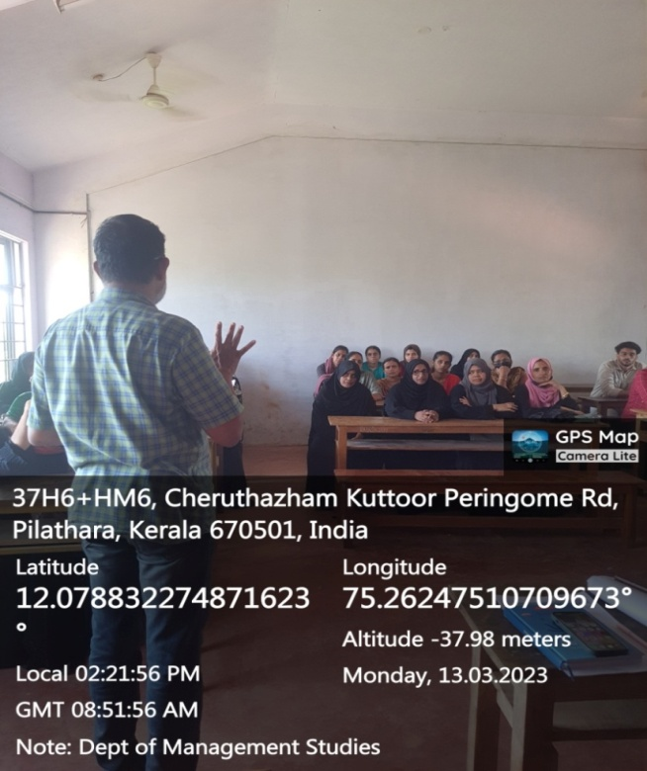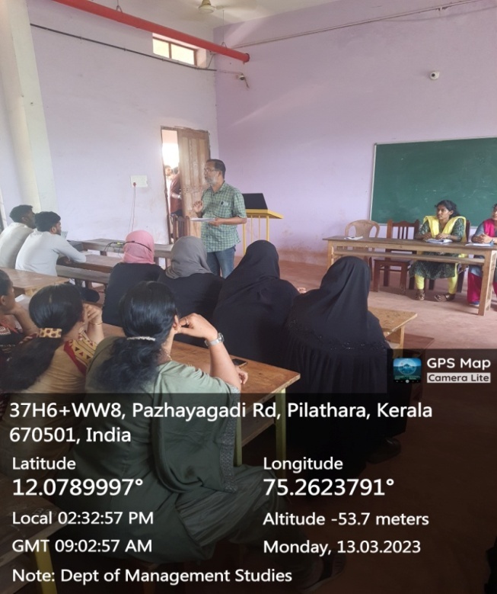
STUDY TOUR
