**DEPARTMENT OF MANAGEMENT STUDIES**

**EVALUATION REPORT 2019-2020**

**FACULTIES**

* M GREESHMA PAVITHRAN- HOD
* SANGEETH K
* HARITHA RAJEEVAN
* VINIL P VISWANATH

The 2019-2020 journeys started on 6th June 2019. The current academic year witnessed a number of activities. The department has outlined a detailed plan to make the students excel in their academic performance. There was marginal increase in I BBA enrolment, so there were 120 students in the department initially. However due to 3 drop outs in III BBA and 5 each in II BBA and I BBA, at present the department consist of 107 students - 46 girls and 61 boys, well managed by a team of well experienced and dedicated team of teachers.

**CURRICULAR ENRICHMENT**

* Tally ERP 9.0 certification course & communicative English course in collaboration with **Synergy School of Business Skills (A group CADD centre)** Payyannur.
* “Padavu” workshop was arranged by the department on 16-11-19 for **2018-21 batch** led by Mr Prakashan Padiyil & Mr Raghunath
* One day picnic to Munnar on 12-12-2019 along with Industrial Visit accompanied by Ms Greeshma Pavithran and Vinil P Viswanath
* Session on Carrier guidance for III BBA batch on 21-11-19 by **Fr.Sebastian Mathew**
* Best Manager Competition was conducted for III BBA batch by **Global Institute Kochi on 22/11/19**

**TEACHING LEARNING**

* Grooming & Business Etiquette- II BBA Batch on 04/07/19 by **Synergy School of Business Skills**
* Post entry test was conducted for I BBA batch on 19 /07/2019
* Bridge course started for I BBA from 30/07/19 to 16/08/19
* Session on Taxation on for II BBA & III BBA batch 13/11/2019 by **Synergy School of Business Skills**

**STUDENTS ACHIEVEMENTS’**

Our students got ample opportunities to excel in co curricular activities. They exhibited their talents in university Kalotsavam and other cultural programmes. 31 students from the department took active participation in inter collegiate competition such as management fest, IT fest etc.

* **Rahul Ramanan** (III BBA)’s rare collection of ‘Theyyyam’ photos exhibited in the book fair organised by Malayalam Dept on 06/02/20
* **Navaneeth Jay (I BBA)** secured **first (Cash prize 2000) in photography competition** in the National Level Management **fest “Dextra 2k19” organized by SIR SYED College** Taliparamba
* **UNIVERSITY KALOLSAVAM PARTICIPANTS**
* Akhila A K (II BBA) Mappilapatu
* Muhammed Halfas M (I BBA) Duff
* Muhammed Afsal K (I BBA) Duff
* Irfad Ibrahim (I BBA) Duff
* Sabin V P (I BBA) English Drama
* **Sports Stars**
  + *COLLEGE FOOTBALL TEAM* **: Nihal VV (II BBA), Muhammed Bilal (II BBA)**
  + *NORTH ZONE SHUTTLE BADMINTON CHAMPIONSHIP RUNNERS UP*- **Muhammed Bilal (II BBA)**

**STUDENT’S CONTRIBUTION**

* **College promo video : Rahul Ramanan & Girish Ganesh (III BBA)**
* **Water Cooler :** III BBA Batch **(2017-2020 Batch)**
* **Data collection Cheruthazam Service Co-Op BaNK-08-feb 2020**
* Abdul Vahid APT (I BBA)
* Muhammed Ameen (I BBA)
* Junaid (I BBA)
* Muhammed Halfas (I BBA)
* Thameema (I BBA)
* Sinta Mariya(I BBA
* **Gifted memento** “WE SMILE “ Charitable Trust for Disabled”

**By I BBA Batch**

* **Blood donors** of the department include: Muhammed Bilal & Nihal VV from II BBA, Muhammed Afsal ,Ibrahim Ismail ,Irfad Ibrahim, Muhammed Mustafa, Muhammed Ameen ,Muhammed AT & Muhammed Shaheen Abbas from I BBA

**MEGA EVENT**

The department succeeded in its second attempt in hosting the most spectacular and exciting event “**E N T R E P O T 2020**”on 20/01/20 ,entrepreneurship workshop which focuses on developing entrepreneurial and employability skills among youth and enable easy access to entrepreneurship networks.

Former Principal Msgr Clarence Palliath, Vicar General, Kannur Diocese lighted lamp. ENTREPOT 2020 is a modified version of 2k19, which highlighted:

* **Meet the Entrepreneur** : **T N M Javad,Chairman TNM Group of companies**
* **Idea Incubation** isan activity oriented idea generation programme conducted **Smitha RK, ILO SIYB Trainer** and Industry Extension Officer Kalliasseri Block **& Shibu Shine VC,ILO Certified SIYB Trainer** and Industry Extension Officer Athiyannur Block
* **Idea Hunt competition**

**RESULT ANALYSIS**

In the academic year 2019-2020, out of 31 attendees, 8 girls and 2 boys cleared the BBA degree with pass percentage of 32.25%(10/31).However 05 students result was with held. Afeefa Backer occupied the first position with 75.5%.

**PTA**

Parents Teachers Meetings are held at each semester to review the activities of students and seek parent’s feedback. From I BBA batch, Mrs. Saleena Jhonson, parent of Abhilash Jhonson and Mr. Mohanan K V, parent of Aiswarya were selected as PTA representatives.

|  |  |
| --- | --- |
| **SEMESTER** | **DATE** |
| I | 18/10/19 |
| II | 03/03/20 |
| III | 06/08/19 |
| IV | 16/01/20 |
| V | 29/07/19 |
| VI | 15/01/20 |

**TEACHER PROFILE AND QUALITY**

**Ms M.GREESHMA PAVITHRAN**

* Attended **two day national seminar** on **“Sectoral Reforms and Impact on Indian Business”** held at **Govt.Brennen College, Dharmadam** on 5th and 6th Nov 2019.
* Attended **one day workshop** on **“Practical Approach to GST and Income Tax”** held at **Nirmalagiri College, Kuthuparamba** on 16th July 2019.
* Attended **“GURU-SHISHYA two day Faculty Development Program”** held at **LEAD College** of Management on 30th Nov & 1st Dec 2019.
* Attended **one day workshop** on **“The Technical Problems and Prospects of Academic Publications”** held at **E.K Nayanar Memorial Government College, Elerithattu** on 4th Oct 2019.

**SANGEETH K**

* Participated **as a Resource person** in UGC sponsored **“Orientation to the Mentee Institutions “** organized by **Nehru Arts and Science College Kanhanagad** on 06th Feb 2020

**VINIL P VISWANATH**

* Participated in **two days national seminar** on **“Business and Management in Contemporary Indian Scenario”** organized by **Sir Syed College ,Taliparamba** on 25th and 26th Feb 2020
* In charge of College **ED Club**

**PHOTO GALLERY**

**2017- 2020 BATCH**

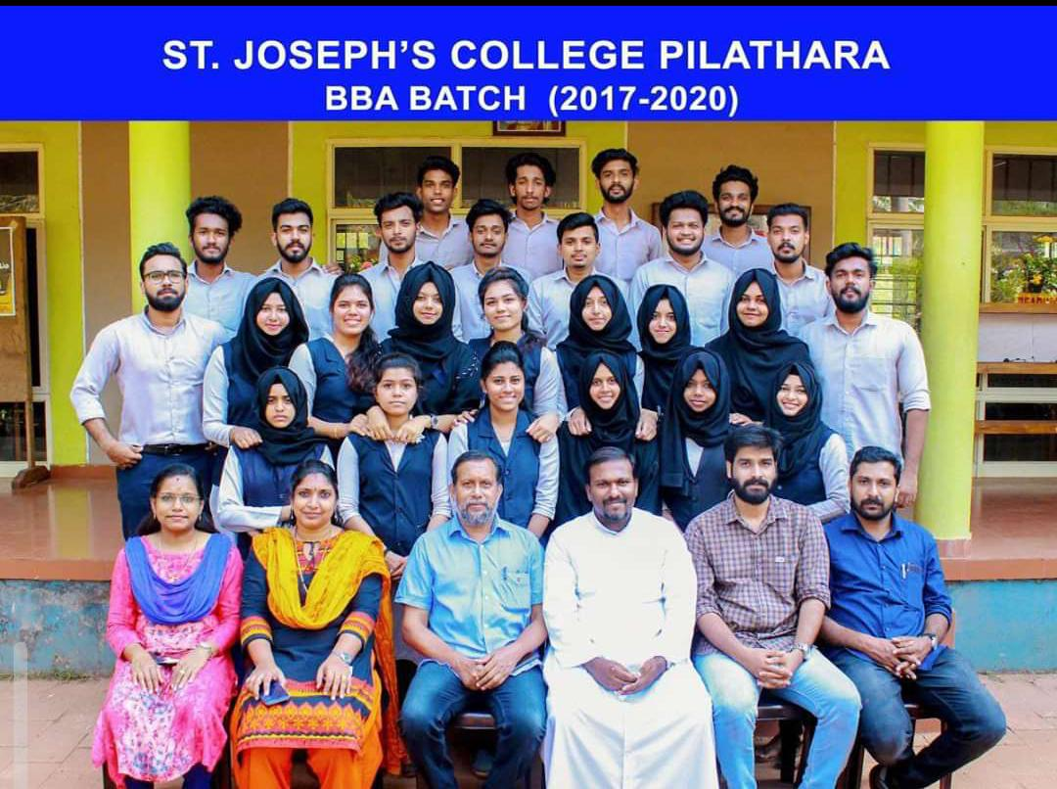

**Padavu workshop**

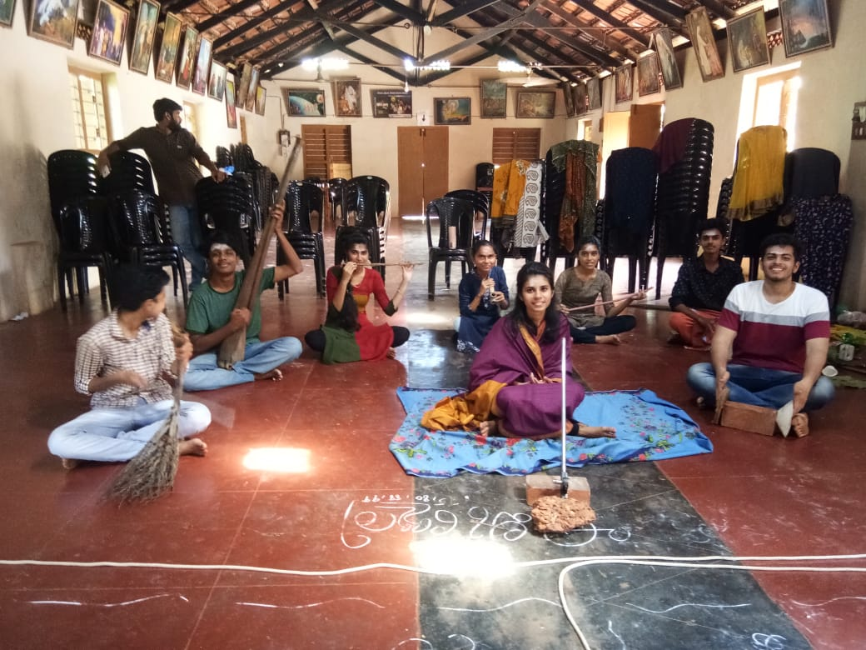 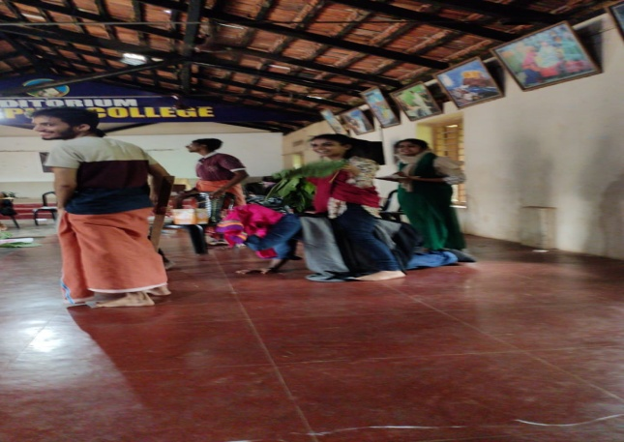

**MUNNAR TRIP**

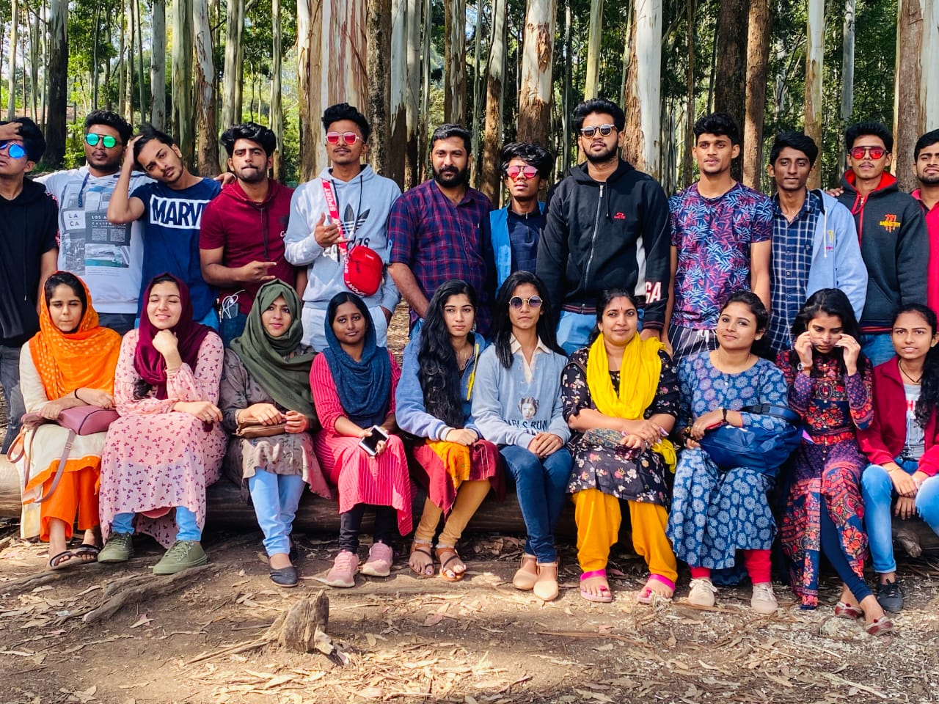

**INDUSTRIAL VISIT**

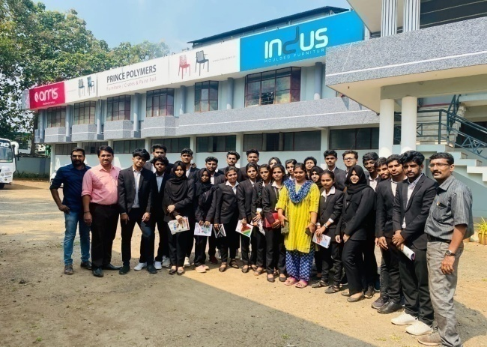 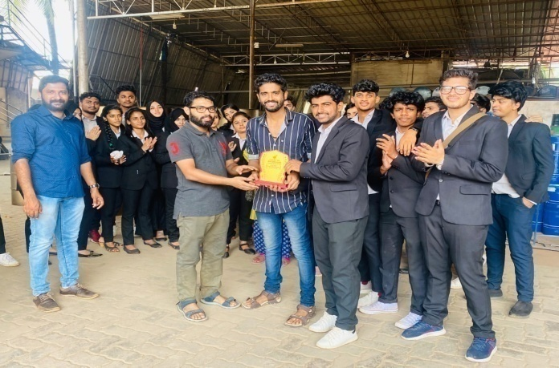

**WATER COOLER INAUGRATION**

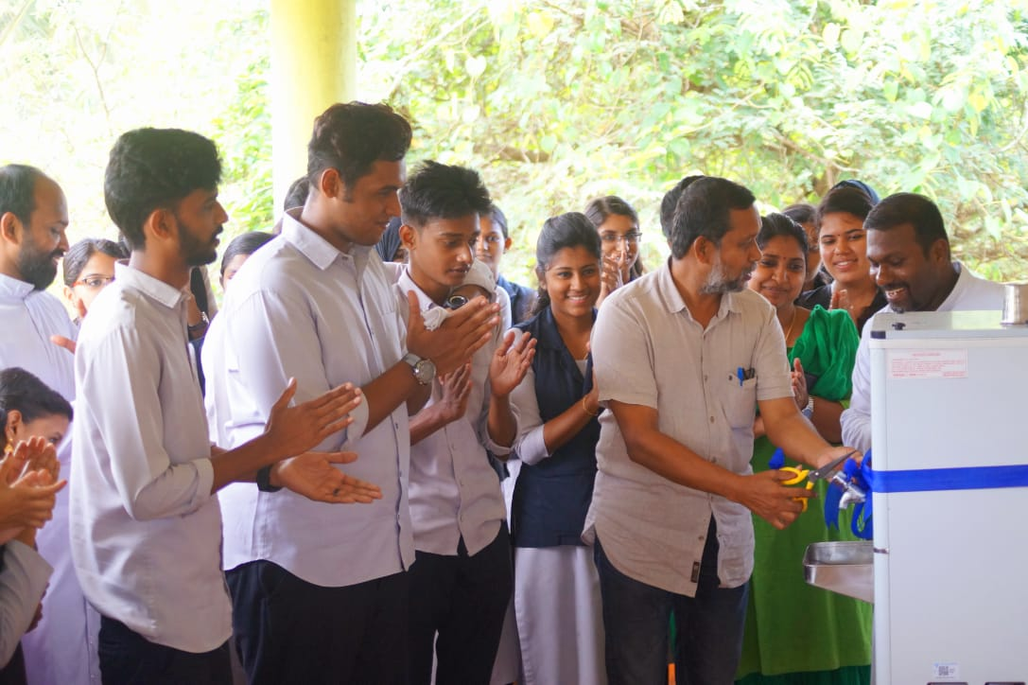

**GIFTING MEMENTO- WE SMILE**

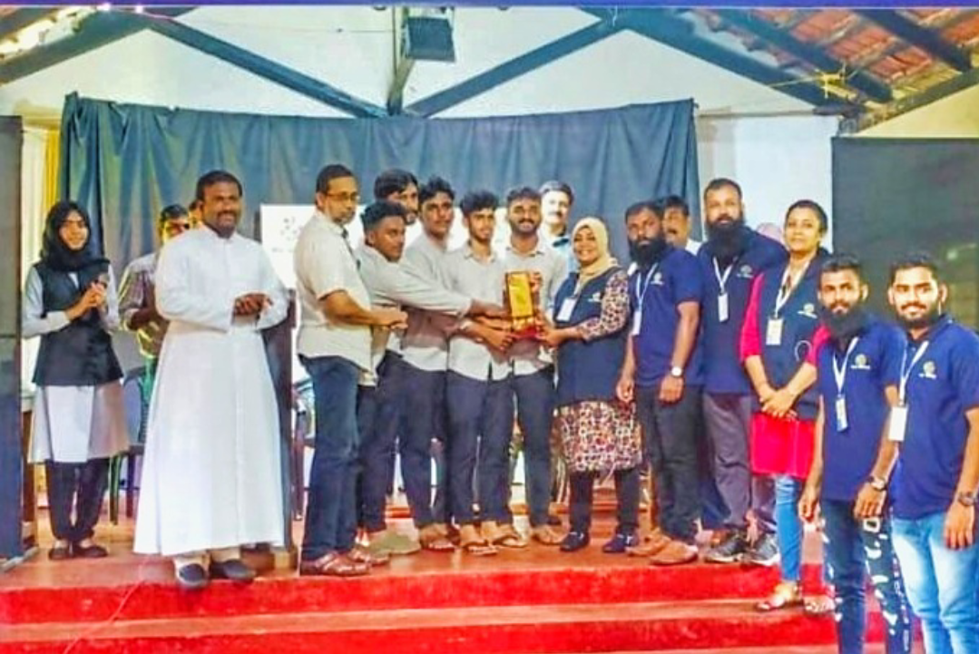

**ENTREPOT 2020**

